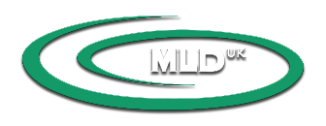
Lymfund Guidelines for MLD^{UK} Therapists

What is Lymfund about?
- The aim of the Lymfund is to help provide MLD treatments for patients who, otherwise, couldn’t afford them.

How much will I receive?
- The sum of £550 will be awarded for 10 sessions (approx. 10 hours at £55.00). You may NOT charge the patient a ‘top-up’ fee to increase your earnings.
- This sum applies only to MLD and does not cover the application of bandages/assistance in acquiring compression garments etc. – this would be the choice of the therapist.
- The funding is recommended for an intensive course of treatments rather than maintenance which could be spread over weeks or months.

How do I apply?
- Fill in the Application for Funding form stating the planned duration of the treatment.
- Submit the form to the MLD^{UK} office.

What happens next?
- Members of the MLD^{UK} Committee will consider your application.
- You may be contacted by the Committee for further clarification.
- Notice of a successful application will be sent to you in writing or by email and you may then commence treatment.
- If your application is refused, you will receive notification in writing. No treatment should commence.
- Only one application per patient per year will be considered.

How do I get paid?
- Submit the Lymfund Treatment Completion form to the MLD^{UK} office on completing all the treatments.
- Payment will be transferred to your bank account.
PLEASE NOTE: serving MLD^{uk} committee members may NOT apply for the Lymfund

